Day 3: Teaching Your Robocar to See

Table of Contents
Day 3: Teaching Your Robocar to See
Table of Contents
How to Make Your Robocar React To Things It Sees
Add a Loop Block
Add a Switch Block
Configuring the Switch Block To Use the Ultrasonic Sensor
Adding Blocks to the Switch
Getting the Switch Block to Decide which path to use
Using the Slider to Adjust Decision Distances
Challenges
Challenge One: Go Into a Garage
Challenge Two: Back Into a Garage
Challenge Three: Drive A Lap Around The Track

How to Make Your Robocar React To Things It Sees

Add a Loop Block
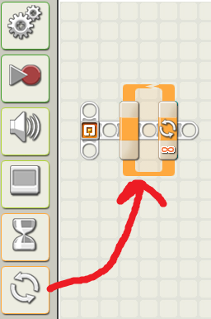Anything inside a loop block gets repeated over and over.

Add a Switch Block
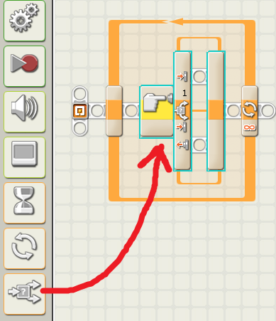A switch block lets the robocar decide between two courses of action, either the top or the bottom.

Configuring the Switch Block To Use the Ultrasonic Sensor
Be sure the sensor for the switch block is set to Ultrasonic Sensor.
Be sure the Port is set to the number of the port on your robocar into which the Ultrasonic sensor is plugged. It should be port 3.
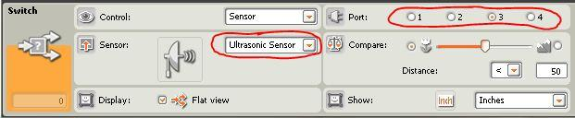

Adding Blocks to the Switch
You can put any type of blocks inside the switch block. We will put a stop block in the top and an unlimited move block in the bottom.
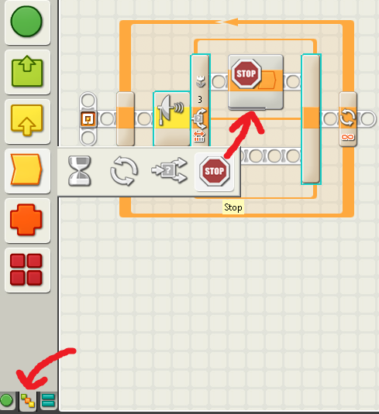

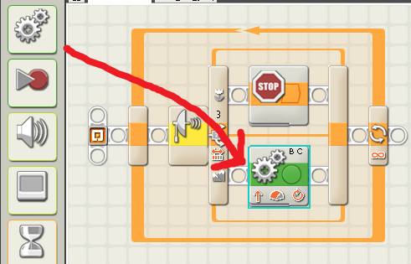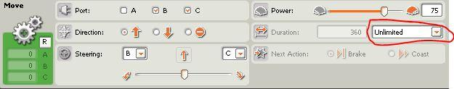The unlimited move block is special because it will make the robot keep going forward as long as there is nothing in front of it.

Getting the Switch Block to Decide which path to use
Click on the switch block again.

The robocar will take the Mountain path and move forward if anything is more than 50 inches in front of it.
The robocar will take the Flower path and stop if anything is closer than 50 inches in front of it.
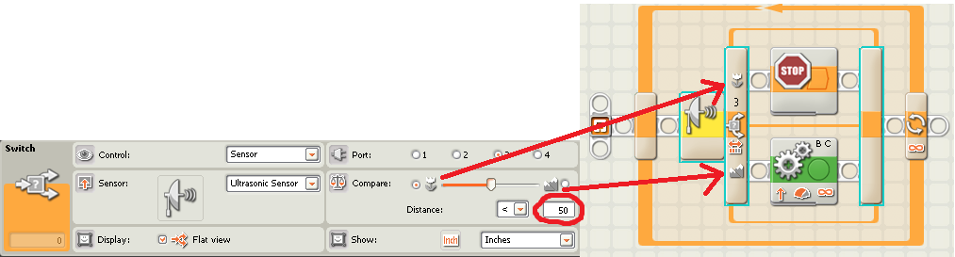

Using the Slider to Adjust Decision Distances
Adjust this slider to change what the robocar considers path and what the robocar considers path. In this example, the robocar will now take the flower path if anything is closer than 10 inches in front of it.
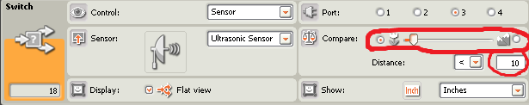

Try it out! This program should allow you to complete challenge one.

Challenges

Challenge One: Go Into a Garage
Starting from behind any of the three starting points, have your robocar drive into the garage across from it without touching any of the garage walls. Use the ulttrasonic sensor to know when to stop.

Challenge Two: Back Into a Garage
Do the same as challenge one, but have your robocar turn around and back into the garage once it gets close, again without touching any of the garage walls. Use the ultrasonic sensor to know when to turn around and back in.

Challenge Three: Drive A Lap Around The Track
Starting from any point on either track, your robocar must go all the way around the track without touching the inner or outer wall of the track.

