Day 2: Teaching Your Robot To Move

Table of Contents

Day 2: Teaching Your Robot To Move
Table of Contents
Opening the Program
List of the Basic Types of Robot Movement
Move Forward
Move Backward
Turn Left
Turn Right
Duration: How it Works
Challenges
Challenge One: Go Into a Garage
Challenge Two: Back Into a Garage
Challenge Three: Drive A Lap Around a Track
Bonus Challenge: Drive A Lap Backwards Around a Track
Troubleshooting
Trouble Downloading to the Robot
Deleting a Command Block
Not Enough Room To Add More Block
Out of Memory Error
Program is Behaving Much Differently Than Expected

Opening the Program
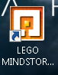Double-click the Lego Mindstorm NXT icon on your desktop
.

List of the Basic Types of Robot Movement

Move Forward
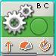Changing the duration changes how far forward the robot will go.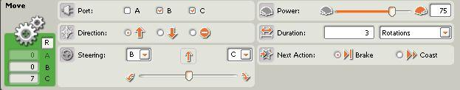

Move Backward
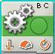Changing the duration changes how far backward the robot will go.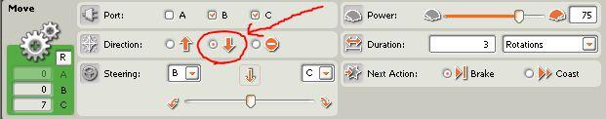

Turn Left
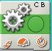Moving the steering all the way to the left causes the robot to turn to the left sharply in-place. Changing the duration changes the amount of turning around the robot will do. It may spin in circles if the duration is high enough.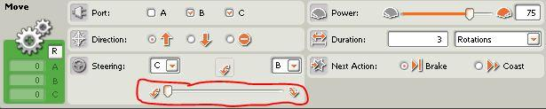

Turn Right
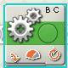Moving the steering all the way to the right causes the robot to turn right sharply in-place. Changing the duration changes the amount of turning around the robot will do. It may spin in circles if the duration is high enough.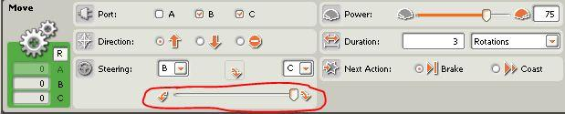

Duration: How it Works
- Unlimited - causes the robot to keep moving forever
- Degrees - How many degrees the wheel will spin before stopping
- Rotations - how many times the wheels will fully rotate(spin) around before stopping
- Seconds - the number of seconds the wheel will spin before stopping

Challenges

Challenge One: Go Into a Garage
Starting from behind any of the three starting points, have your robot drive into the garage across from it without touching any of the garage walls.

Challenge Two: Back Into a Garage
Do the same as challenge one, but have your robot turn around and back into the garage once it gets close, again without touching any of the garage walls.

Challenge Three: Drive A Lap Around a Track
Starting from any point on either track, your robot must go all the way around the track without touching the inner or outer wall of the track.

Bonus Challenge: Drive A Lap Backwards Around a Track
As a bonus if you finish the first three challenge, try to do challenge three but having you robot go backwards instead of forwards for the whole time.

Troubleshooting

Trouble Downloading to the Robot
If you are having trouble downloading to the robot, trying turning the robot off and then turning it back on again.

Deleting a Command Block
To delete a block, select the block and press the Delete key.

Not Enough Room To Add More Block
Use the arrow keys to scroll left or right for more room. 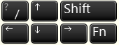

Out of Memory Error
To fix the “The NXT device is out of memory” error:
- Click the Manage Files button.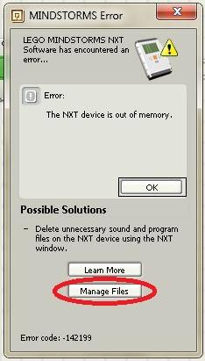

- Click on Program.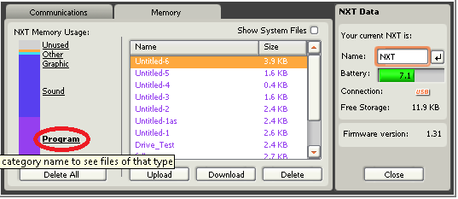

- Use the Delete button to delete all the unneeded programs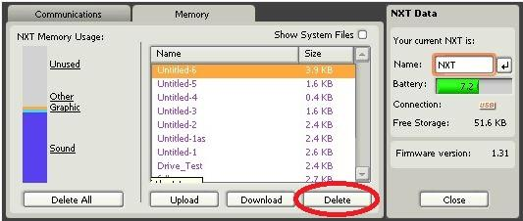

- Close the box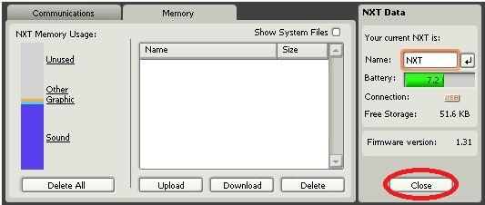

- Everything should work fine now

Program is Behaving Much Differently Than Expected
If you haven’t done so already, try saving your program under a unique name so that you do not accidentally run another program on your robot with a similar name. Otherwise, there may just be an error in the program you wrote.Use the arrow keys to scroll left or right for more room.

