Day 1: Building Your Robocar

Table of Contents

Day 1: Building Your Robocar
Table of Contents
Instructions
Building the Robot
Testing the Robot
Extra Fun
Trouble Shooting
Trouble Downloading to the Robot
Deleting a Command Block
Not Enough Room To Add More Block
Out of Memory Error

Instructions

Building the Robot
- Find out whether you have an NXT 1.0 or NXT 2.0 robot. To do this, look at the tires available for your robot.
  - NXT 1.0 Tires are bumpy:
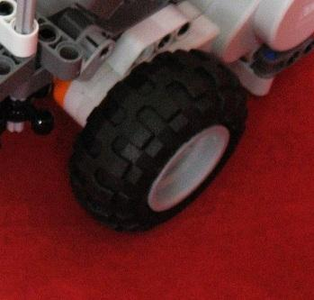

  - NXT 2.0 Tires are flat and smooth:
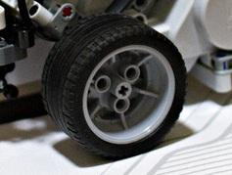Image Copyright © chauromano of flickr.com

- Build you robot using the online instructions below:
  - For NXT 1.0, go to http://www.nxtprograms.com/five_minute_bot/steps.html and follow the steps to build the five-minute bot.
  - For NXT 2.0, go to http://www.nxtprograms.com/NXT2/five_minute_bot/steps.html and follow the steps built the five-minute bot.

Testing the Robot
- Download the five-minute bot drive test program Drive_Test.rbt by clicking on this link: http://www.nxtprograms.com/programs/Drive_Test.rbt .
- When Drive_Test.rbt finishes downloading, click on it to open it using the Lego NXT software.
- Once the NXT software finishes loading, your screen should look like this:
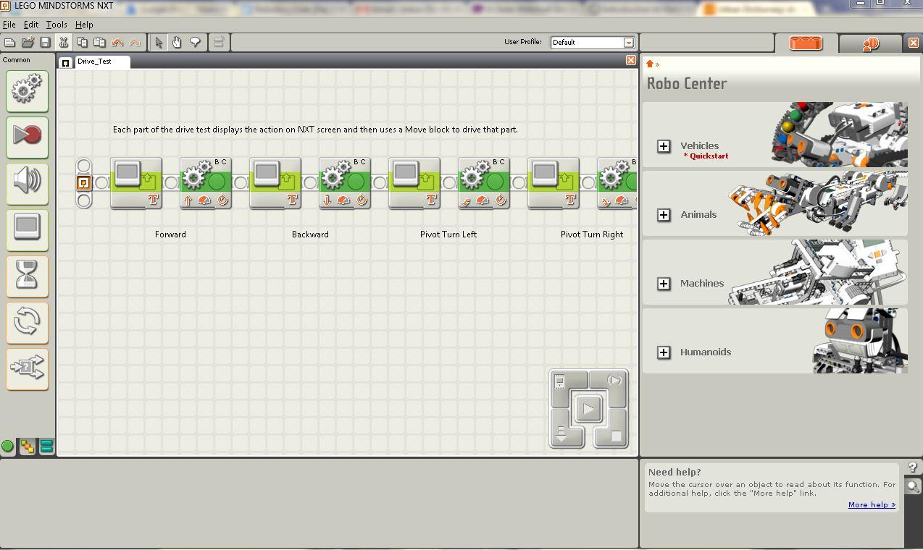
- Next, Plug your robot into the computer using the USB cable.
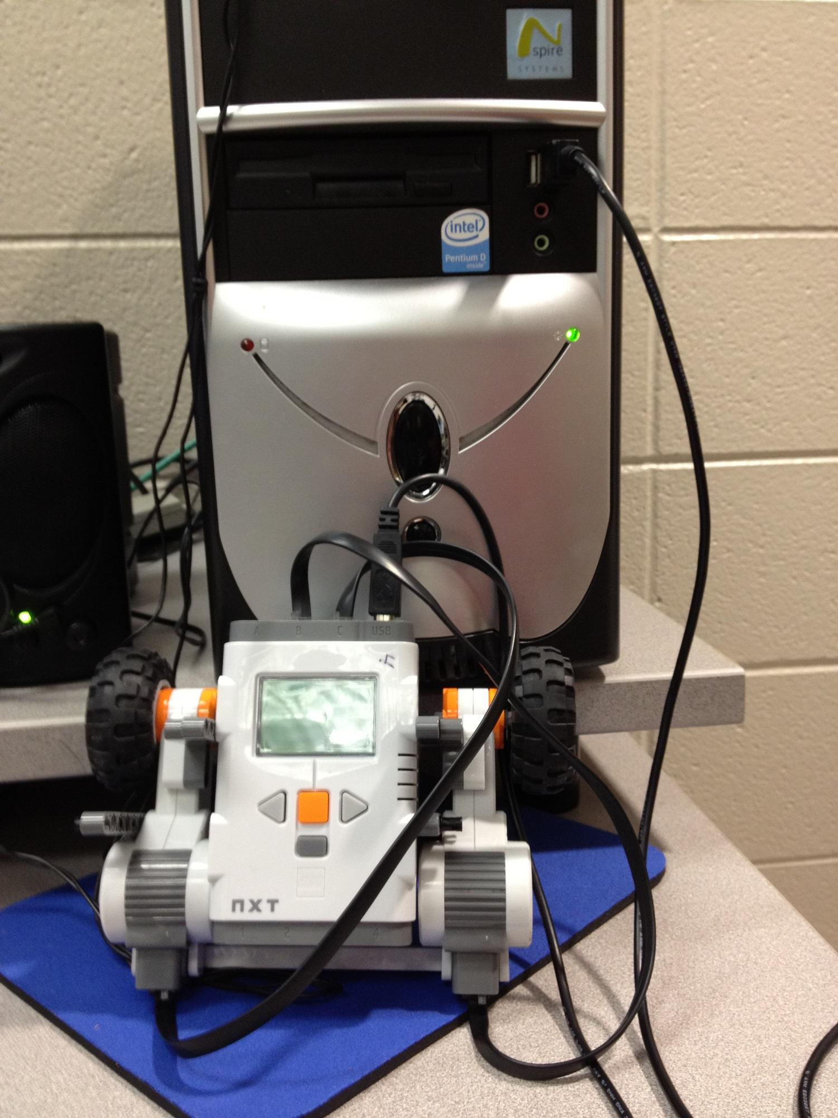

- Turn on the robot by pressing the big orange button on the robot.
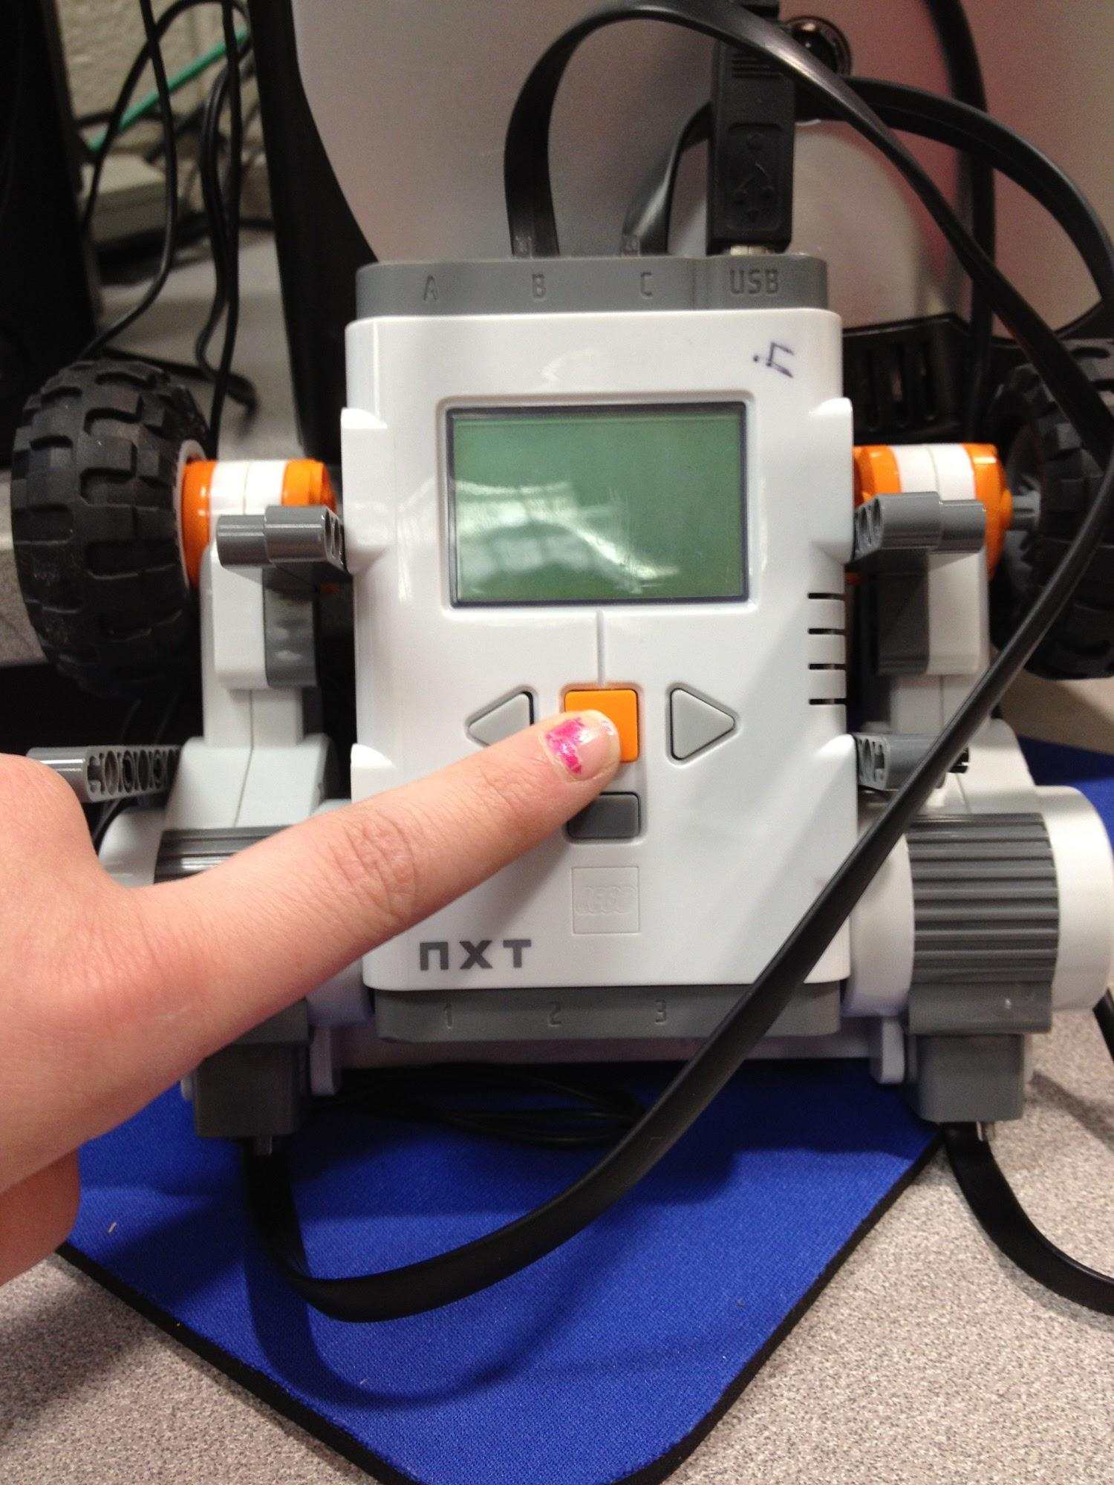

- Press the download button in the NXT software to download Drive_Test.rbt to your robot.
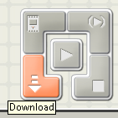

- Unplug your robot from the computer and set in on the floor.
- On your NXT robot, use the buttons to go to My Files > Software Files > Drive_Test and then run Drive_Test.
- Your robot should automatically move forward, backward, left, and right.
- You are done, but there is extra fun below.

Extra Fun
- If you finish before the end of class, try changing different things in Drive_Test.rbt and re-running the program to see what happens. (See the pictures below for ideas on what can be changed)
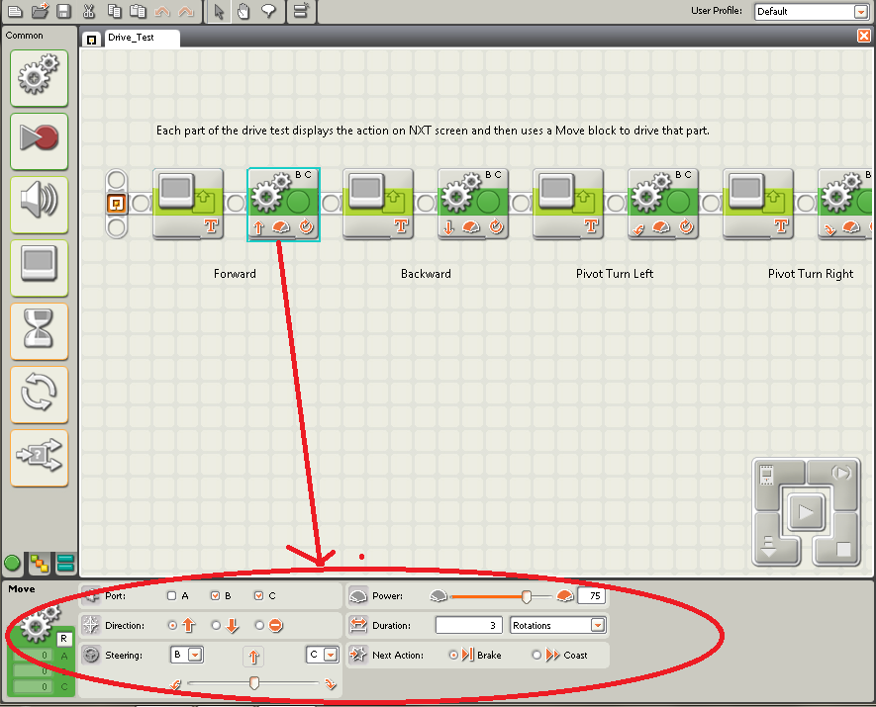
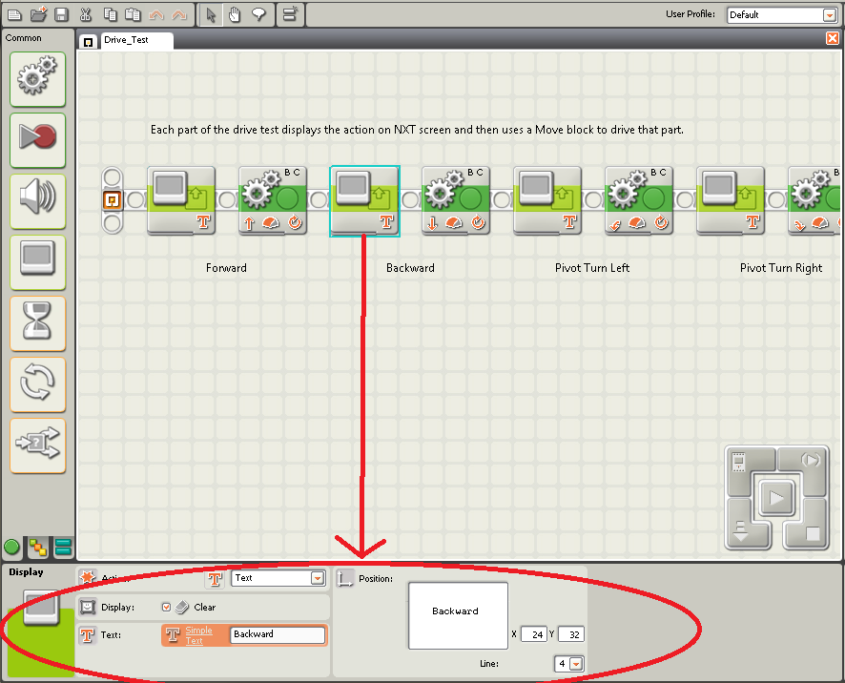

Trouble Shooting

Trouble Downloading to the Robot
If you are having trouble downloading to the robot, trying turning the robot off and then turning it back on again.

Deleting a Command Block
To delete a block, select the block and press the Delete key.

Not Enough Room To Add More Block
Use the arrow keys to scroll left or right for more room.
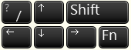

Out of Memory Error
To fix the “The NXT device is out of memory” error:
- Click the Manage Files button.
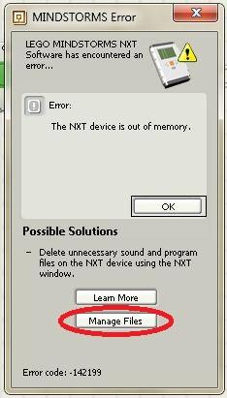

- Click on Program.
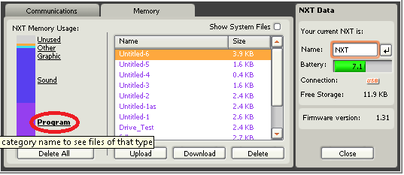

- Use the Delete button to delete all the unneeded programs
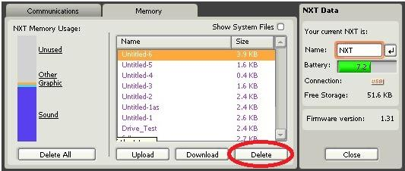

- Close the box
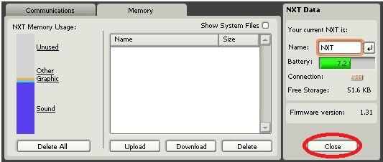

- Everything should work fine now

