Scratch Exercise 3: Making Friends: Interaction between Sprites

We want to have two sprites interact with each other and become friends.

Step 1: (Optional) Save Your Old Project
1. Click on File -> Save
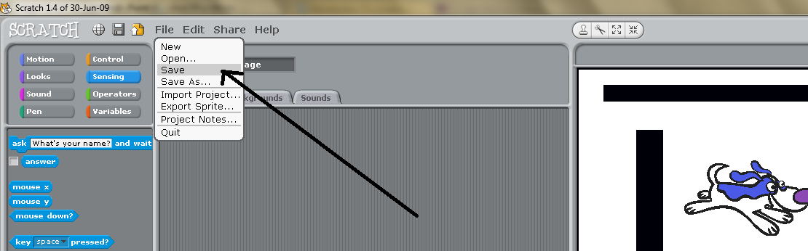

2. Give your project a name and then press “Ok” to save
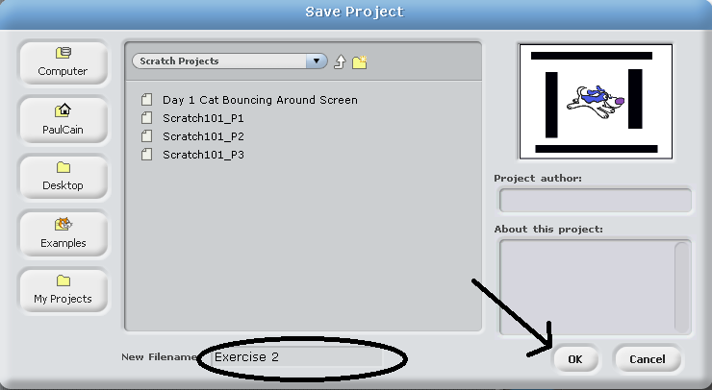

Step 2: Create a new Scratch Project
1. Click on File -> New
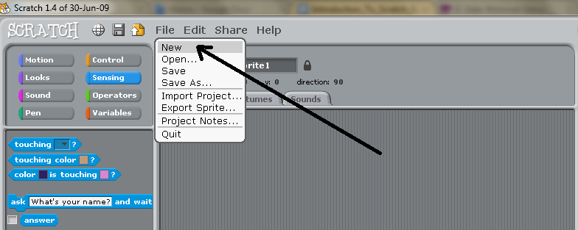

2. A new project should appear with just the cat.
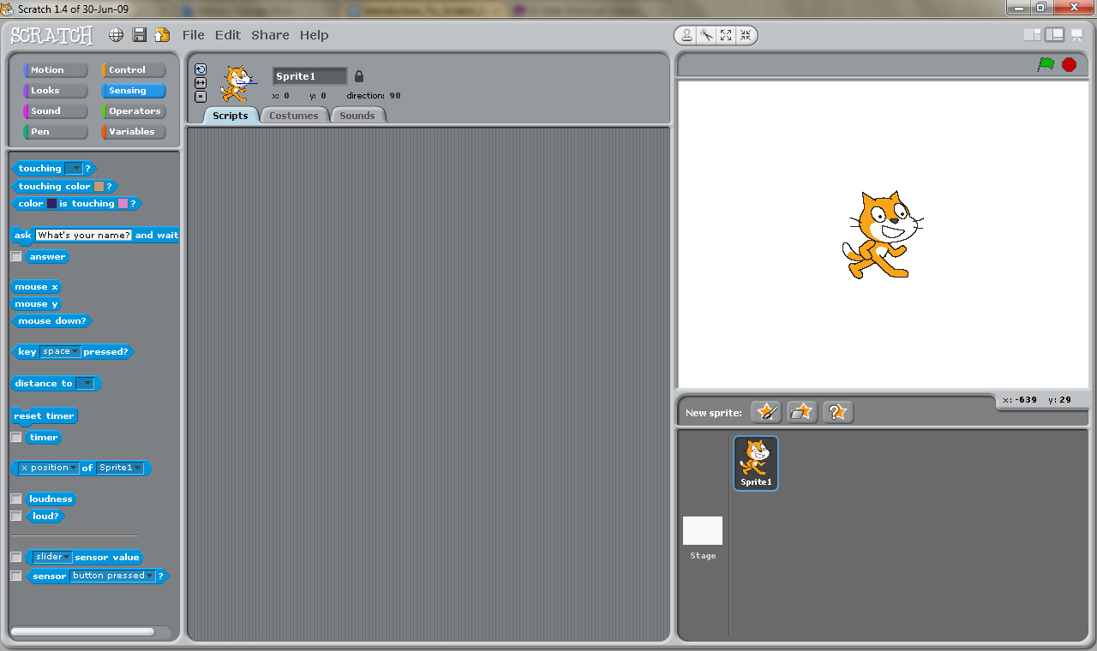

Step 3: Adding Your Character
1. Change the name of the cat from “Sprite1” to “Cat”.
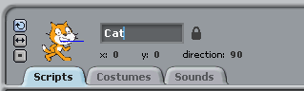

2. Add another sprite to the stage. We will use Square Guy.
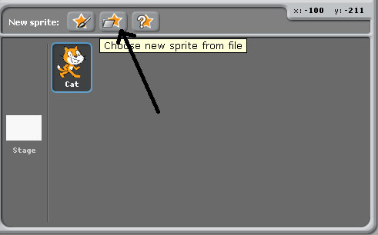
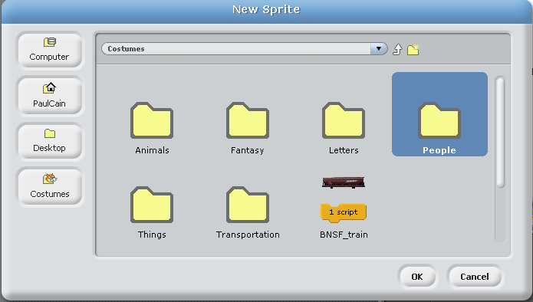
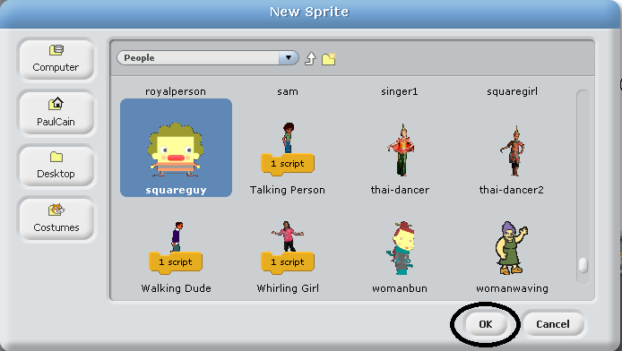

3. Change the name of your sprite to Square Guy
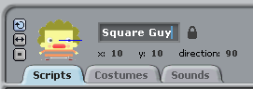

Step 4: Adding a Background
Since we do not want the characters to be floating in nothing, let’s add a background.
1. First, click on Stage
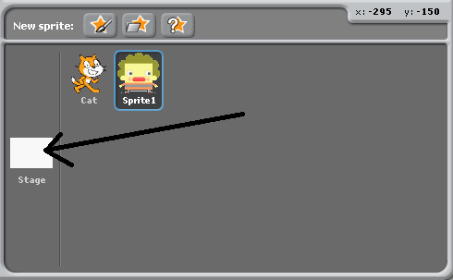

2. Select the Backgrounds tab
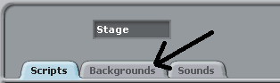

3. Click the import button
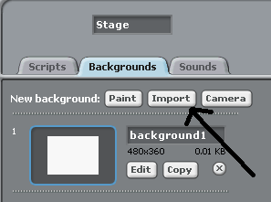

4. Select a background you like
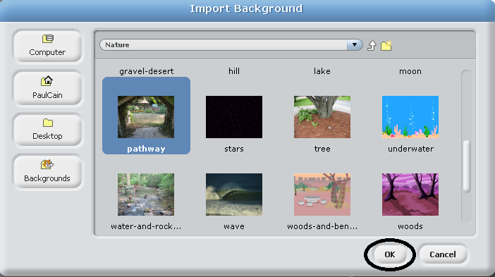

Step 5: Arranging Our Characters
1. Drag Square Guy to the lower-left corner of the screen
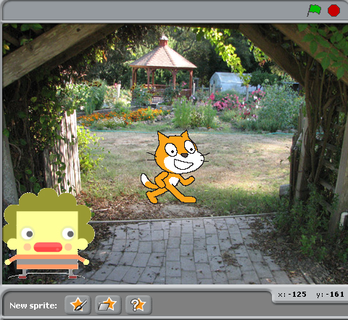

2. Drag the cat to the lower-right corner of the screen
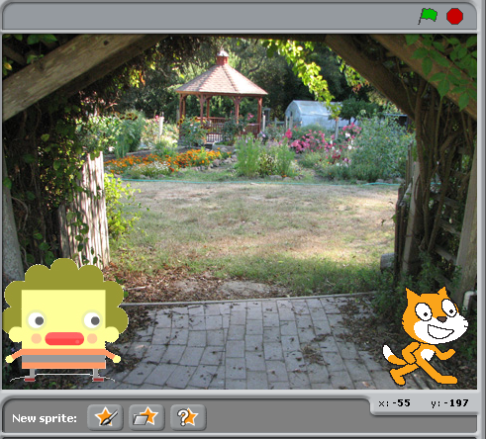

Step 6: Starting a Conversation
Let’s start by having Square guy call to the cat.

1. Be sure Square Guy in highlighted in blue
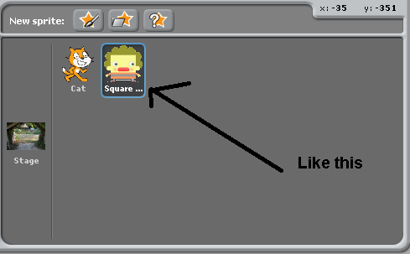

2. From the control menu, drag a “when green flag clicked” block into the scripts field
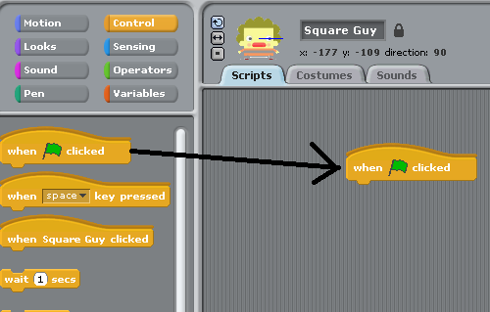

3. From the looks menu, drag a “say” block into the scripts field and connect it with the “When green flag clicked” block
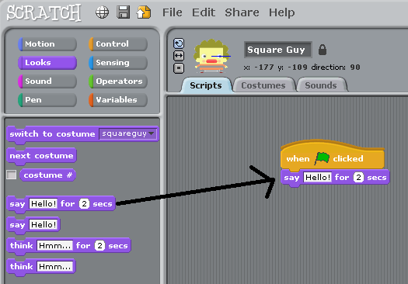

4. Change text in the say block from “Hello!” to “Hey. A cat. Here kitty!”
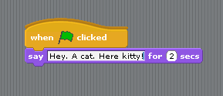

5. Press the green flag to watch Square Guy call to the cat
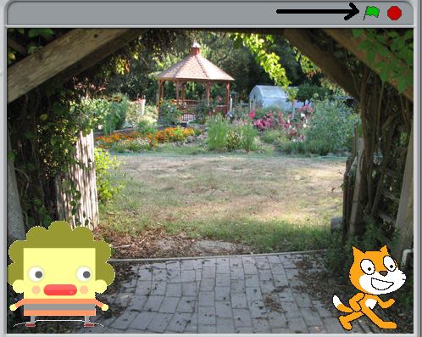

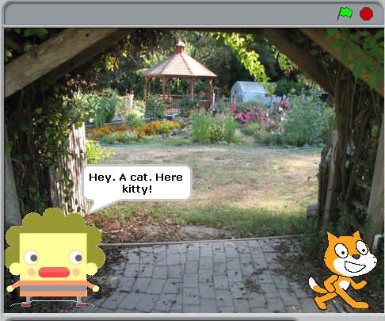

Step 7: The Cat Responds
Now let’s tell the cat to respond to Square Guy by turning around and meowing. To do this we will do broadcasting and receiving. Broadcasting and receiving is how sprites communicate with each other. You can think of it like sending text messages to your friends or passing notes in class.

1. From the control menu, drag a broadcast block into the scripts field and connect it. 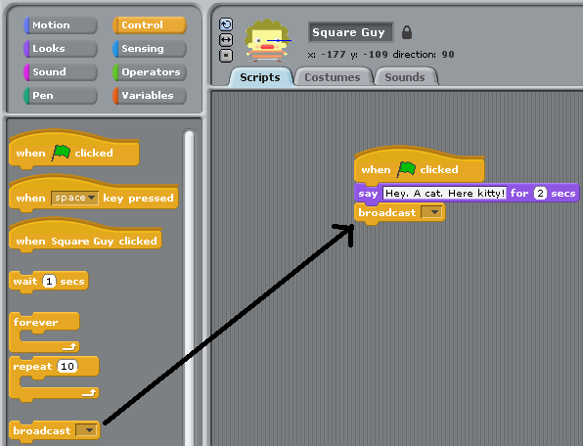

2. Click the black triangle in the broadcast block to give a name to the broadcast. All broadcasts need a unique name.
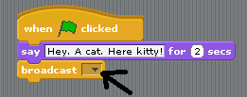

3. Although you can name the broadcast anything you want, we will name this broadcast “Here Kitty!” and then press ok.

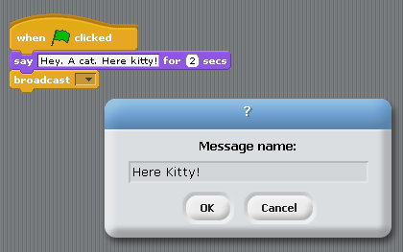
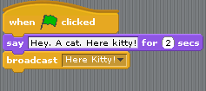

4. Now the cat can respond to the broadcast. Select the Cat sprite and drag the when I receive “Here Kitty!” block into the scripts field.
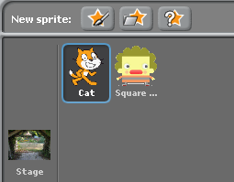
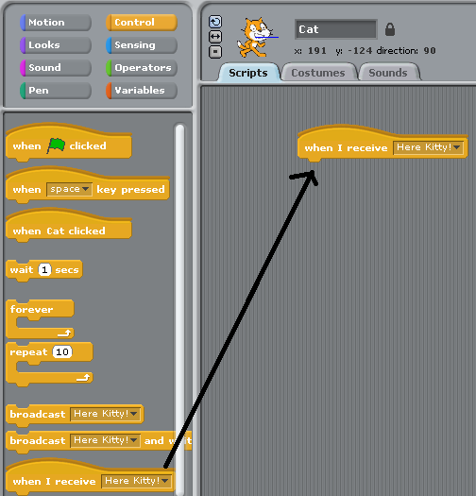

5. Click the "just flip left-right" icon to make the cat only turn left or right.
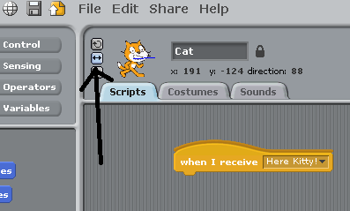

6. In the motion menu, click on the dark triangle on the “point towards” block to change it from nothing to Square Guy.
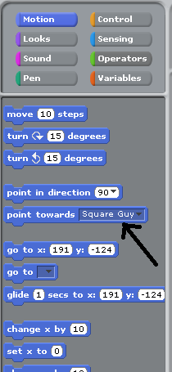

7. From the motion menu, drag the point towards block into the scripts field and connect it.
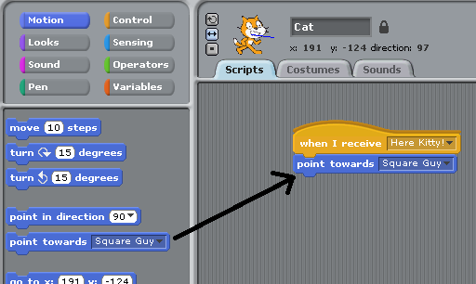

8. From the looks menu, drag a say block into the scripts field, connect it, and change the text to “Meow!”.
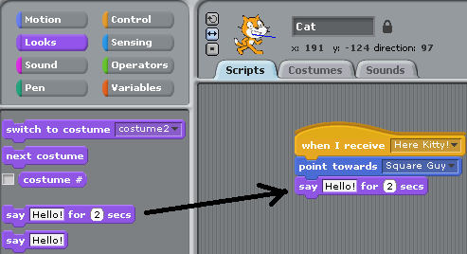
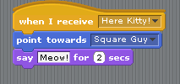

9. Click the green flag to watch Square Guy call to the cat and watch the cat to turn around and meow at him.
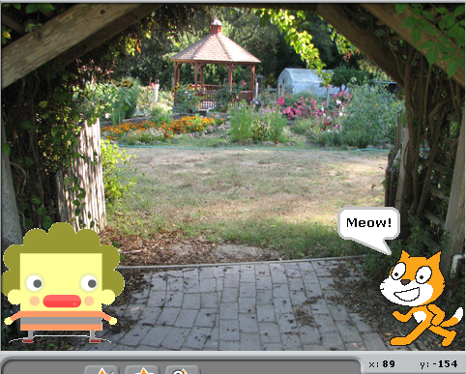

Step 8: Square Guy and the Cat Become Friends
Now let’s have Square Guy respond to the cat’s meowing by meowing back at the cat, sealing their friendship.

1. From the control menu, add a broadcast block named “Cat Meows” to the scripts field and connect it.
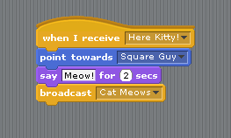

2. Select Square guy again and drag a receive block in the scripts area to receive the cat’s Meow.
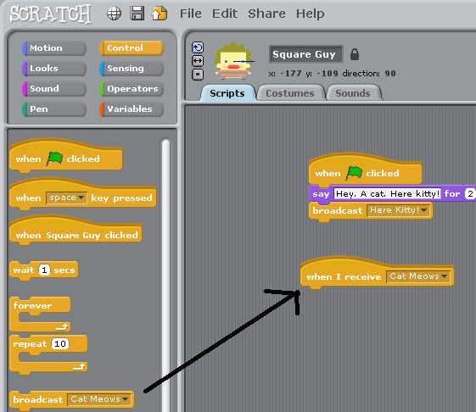

3. From the looks menu, add a say block that says “Meow Meow Meow Meow =^_^=” and connect it.
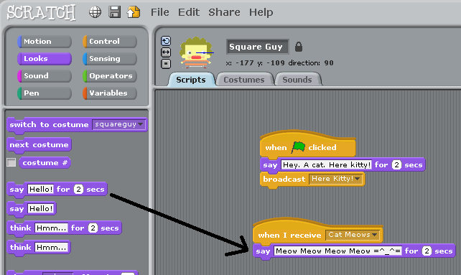

4. Click the green flag to watch Square Guy call to the cat, the cat to turn around and meow at him, and then Square Guy meow back at the cat. Now they are friends who can broadcast and receive to each other all day long, doing many fun things.
