GK-12 STEM Project
Paper Plate Speakers

Objectives
In the course of this activity, students will:
- Exercise the engineering design process by constructing and optimizing a speaker with limited materials
- Develop an understanding of the basic traits of a sound wave
  - amplitude – volume

  - frequency – pitch

Materials

- paper plates
- paper
- scotch tape
- 3” x 5” notecards
- ceramic disc magnets (about 1/4” thick by 3/4” diameter)
- magnet wire
- hot glue gun
- small amplifier and power source (for instance: Lepai LP-2020A+ Tripath TA2020 Class-T Hi-Fi Audio Amplifier)
- male-male audio cable
- computer

Software
- Audacity (free download at http://audacity.sourceforge.net/)

Building your speaker
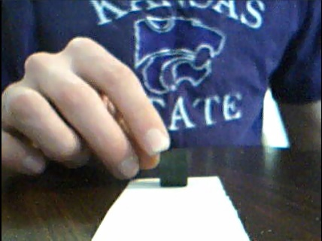
The coil

- Stack four disc magnets together to make a cylinder about an inch tall.
- Make two strips of paper about two inches wide and eight inches long.
- Wrap one strip tightly around the stack of magnets and tape the end down.
- Wrap the other strip around the first strip and tape it down the same way. This second roll will hold your speaker’s coil.
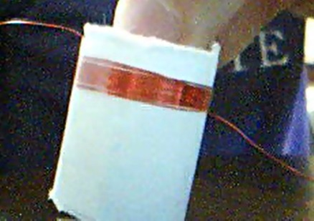
- Cut off about four feet of magnet wire and wrap it tightly around your speaker coil.
- Don't worry too much if you overlap your wire; just try to wrap it evenly across the whole coil. Make sure to leave about six to eight inches on either side so that you can connect your speaker to a signal source later. After your coil is wrapped, tape it in place so it doesn't come unraveled.
- Carefully slide off the outermost role of paper with the coil of magnet wire. Try placing it over one of your magnets. If it moves freely over the magnets, it should work. If it doesn't fit around your magnets, or it sticks a lot, you may have to redo your coil.

The Diaphragm
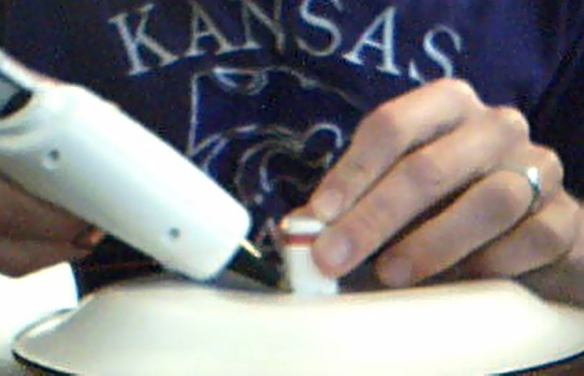
- Place a paper plate upside down in front of you.
- Find the center of the plate.
- Hot glue your speaker coil to the center of your plate. This plate will serve as the diaphragm for your speaker.

The Speaker Body
- Fold two notecards in to an “M” shape.
- Tape the notecards on to your speaker diaphragm (paper plate) on either side of your coil so that the “M” is on its side and the legs of the “M” are pointed in towards the coil.
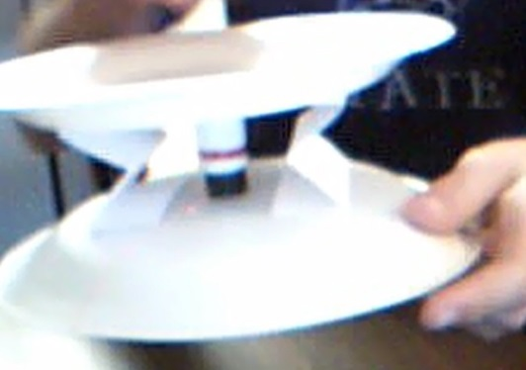
- Tape another plate on to the other side of the notecards so that it is suspended directly above your first plate.
- Turn the whole speaker over so that the plate with the coil attached is now on top. Place a magnet on either side of the bottom plate. Move the magnets around so that they are sitting right under the coil. If you have enough, make a short stack of magnets so that they are inside the coil.

You now have a working speaker! All we have to do is hook it up.

Connecting to a computer
- Burn the insulation off of the ends of your coil with a small lighter.
- Clip the ends of your coil in to the positive and negative slots for the right speaker on your amplifier.
- Connect the amplifier to your computer with a male-male audio cable.
- Connect the amplifier to a power source.

Your speaker is ready to go! You can play any sound on your computer. The following is a suggestion to show students a visual illustration of the properties of sound waves.

Generating a test track
- Open Audacity.
- On the menu bar, click “Generate,” then “Chirp.”
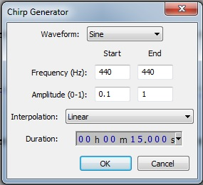
- Generate a tone at 440 Hz whose amplitude increases from 0.1 to 1 in 15 sec.
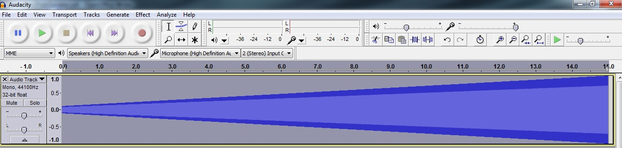
Your track should look something like this:
Now you have a test track to play on your homemade speakers. With this track, you can show students that increasing the amplitude of the sound waves increases the volume of the sound. Try zooming in and playing the track.

If you have time, generate a new chirp (or tone) that is a lower or higher frequency. Show students that lower frequencies have a lower pitch and higher frequencies have a higher pitch.

